JHJDS2022A \ JHJDS2012A handheld digital storage oscilloscope manual

JHJDS2022A \ JHJDS2012A handheld oscilloscope is a portable device developed and produced by JH company. This product is compact, portable, and flexible operation; Using color TFTLCD and pop-up menus to display;to achieve its ease of use, greatly improving the user productivity.
Model | Bandwidth | real-time  sampling rate | The storage depth
JHJDS2012A | Single channel  20MHZ | Single channel  200MSa/s | 2Kpts
JHJDS2022A | Dual channel  20MHZ | Dual channel  200MSa/s | 2Kpts×2
In addition,this product has superior performance and it is powerful, affordable, high cost.The real-time sampling rate can be as high as 200MSa/S,can meet the market demand of complex signals and capture speed;Support for USB storage devices, users can upgrade via USB, the maximum to meet customer needs.

Characteristic:
—New ultra-thin design, small volume, light weight, convenient carrying
—Color TFTLCD display, 320*240 resolution, waveform display more clearly, stability
—Dual analog channel (JDS2012A for single channel)
—Support for USB storage device
—Have the edge trigger function, can automatically detect the support (50Hz - 40MHz)
—Support time and voltage cursors
—Support A variety of waveforms mathematical sum
—Support Chinese and English menu display
—A variety of display styles: color display, monochrome display
—Supports automatic power off and power-saving modes: time can be set
—Backlight brightness can be adjusted
—Waveforms can be saved by screenshot
—Long standby: single cell battery can work continuously for 5 hours
—With a digital multimeter functions (only JHJDS2012A Series)

JHJDS2022A \ JHJDS2012A Series Handheld Oscilloscopes Accessories:
JHJDS2022A： JHJDS2012A：
— Instructions — Instructions
— Certificate — Certificate
— 1: 1/10: 1 probe× 2 — 1: 1/10: 1probe× 1
— Lithium batteries × 2 — Lithium batteries × 1
— Battery Charger — Multimeter pen × 2
— Battery Charger
General safety requirements:

The following safety precautions to avoid injury;And to prevent the product or any other products connected from the damage.To avoid possible danger, be sure to use the product in accordance with the provisions.
Attention: Do not using this oscilloscope (or multimeter) measurements while connecting USB, as this may damage the instrument!
Only trained personnel should perform service procedures.
- Avoid fire and personal injury
● Correct plug
When the probe or test leads are connected to a voltage source Do not plug.
● Properly connected probe
The same probe wire and the ground potential，Do not connect the ground wire to a high voltage.And during the test, do not touch exposed contacts and components.
● View all terminal ratings
In order to avoid the fire and impact of excessive current,Please check all rated the product value and marking instructions.Please refer to the product description before connect the products for more information about ratings.
● Do not open lid
If the cover or panel has been removed, do not operate this product.
● Avoid circuit exposed
After the boot,Do not touch exposed connections and components.
● Suspected product failure, do not operate
If you suspect that the product has failed, you can ask a qualified service personnel.
● To maintain adequate ventilation
● Do not operate in wet conditions
● Do not operate in the flammable, explosive environment
● Please keep the product surface is clean and dry

2. security terminology and labeling
Terminology in this manual. The following terms may appear in this manual:
WARNING: Warning statements indicate conditions and behavior which might endanger the safety of life .
Note: Note Statement Pointed out conditions and behaviors that may cause this product and other property damage .

Terms on the Product: These terms may appear on the product
DANGER: Indicates that there is a direct risk of harm exists near the mark.
WARNING: Indicates a potential risk of injury near the mark.
Note: indicate a potential danger to the products and other property.
Symbols on the Product: These symbols may appear on the product



High voltage Protective ground Attention Measurement of ground
Summary：
This manual describes the operation of JHJDS2022A/JHJDS2012A Series Handheld Digital Oscilloscope.Manual includes the following chapters:
◆ Getting Started: a brief introduction to digital handheld oscilloscope's front panel user interface, functional check and probe compensation.
◆ Features and Operation: a detailed presentation for functions and operations of oscilloscope and multimeter.
◆ The application example: provide some measurement example, for reader reference.
◆ System Tips and Troubleshooting.
◆ Service and Support
◆ Appendix

Chapter I Getting Started
JHJDS2022A/JHJDS2012A handheld digital storage oscilloscope is a small, lightweight portable instrument，To provide users with a convenient and easy to operate front panel, you can perform basic tests.
This chapter explains how to perform the following tasks:
△ Preliminary understanding JHJDS2022A/JHJDS2012A front panel and user interface
△ Brief functional check
△ Probe Compensation
△ Match the probe attenuation factor
1.1 Preliminary understanding JHJDS2022A/JHJDS2012A front panel and user interface
Before using JHJDS2022A/JHJDS2012A,We must first understand the operation panel.Following is a easy description and presentation for the JHJDS2022A/JHJDS2012A series front panel operation and function,To make use of you in the shortest possible time familiar with the oscilloscope.
JHJDS2022A provide users with a clear and simple front panel,To facilitate the user to perform basic operations.Just below the display screen on the panel is marked with various function keys.Which the "MENU" button for the menu operation,It allows you to set the current menu of different options.The Red substrate "PWR" button is the power button,You can press it open or shut oscilloscope.Other keys as function keys,Through them,You can enter different function menus or obtain a specific function application.As shown in Figure 1-1.
JHJDS2012A front panel uses the Chinese menu,the different with JHJDS2022A front panel is,the "CH2" turn into "万用表".As shown in Figure 1-2.
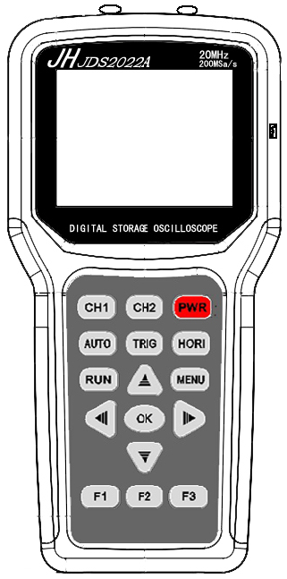
CH1 Port
CH2 Port
USBPort
Trigger
CH2
CH1
Auto
RUN
Scaling
Power
Horizontal
Menu
Move around

Select
Figure 1-1 JDS2022A

COM Port

VΩ Port

CH1 Port
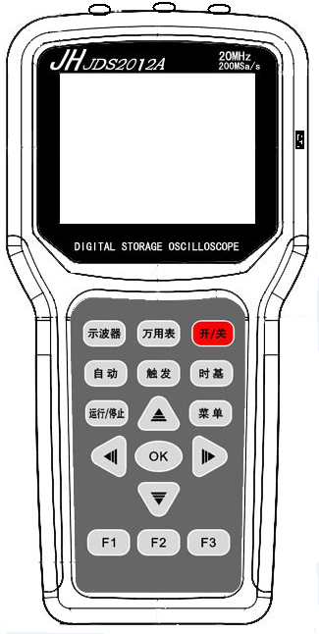
Multimeter
Oscilloscope

Figure 1-2 JDS2012A

Display level
Trigger position

Trigger status display

Show horizontal time / div

Show the waiting time of the trigger signal

Trigger flag

Display power

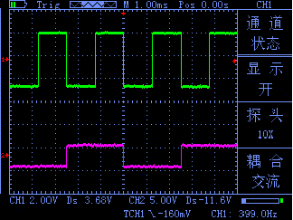
Corresponds to a different function keys, menus will vary

Channel 1 mark

Show the amount of the trigger position

Channel 2 mark

Show vertical volts / division

Horizontal displacement

Figure 1-3 Interface is shown in Figure
1.2 function tests
Perform a quick functional check to verify that the oscilloscope is working properly. Please proceed as follows:
1.confirm the oscilloscope has been installed on the battery,Long press on the oscilloscope panel "PWR" button to let go when the interface to be displayed.
2.Switch oscilloscope probe on the set to 1X and connect the probe with oscilloscope channel 1.The probe connector slot on the convex keys aligned on CH1 coaxial connectors,Press down to connect, and then rotated to the right to tighten the probe.
3.The probe and the probe ground clip connected to the signal generator corresponding connectors(Recommended input 1KHZ, about 3V peak-peak square wave).Press the "AUTO" button.Within a few seconds, you can see the waveform display.In the same way check CH2.
1.3 Probe
1 Safety of probe
Set around the probe body protection to protect your fingers to prevent electric shock.Before taking any measurements, make sure the probe is connected to the oscilloscope and the ground terminal to ground.
2 Probe compensation (see probe manual)
In the first probe with any input channel connection,this needs to be adjusted to match the probe to the input channel.Uncompensated probe calibration can cause measurement error or errors.If you adjust the probe compensation, as follows:
- Set the Probe option attenuation to 10X in the channel menu,The switch on the probe is also set to 10X,And oscilloscope probe connected to channel 1.If using the probe hook-tip, ensure reliable contact with the probe.
(2)Connect the probe tip and the signal generator output connector,Grounding clip and signal generator is connected to the ground connector,Display Channel,Then press the "AUTO" (automatic) button.
(3)Check the shape of the waveform display. As Figure 1-4.




Under compensation Appropriate compensation over compensation
Figure 1-4
- If necessary, adjust the probe and repeat the operation if necessary.

Chapter 2 Describes of the function and operation
In order to effectively use an oscilloscope, you need to understand the scope of the following functions:
2.1 Menus and Control buttons
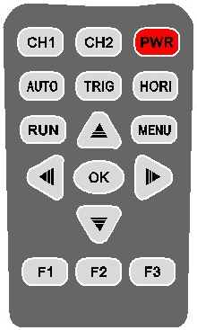
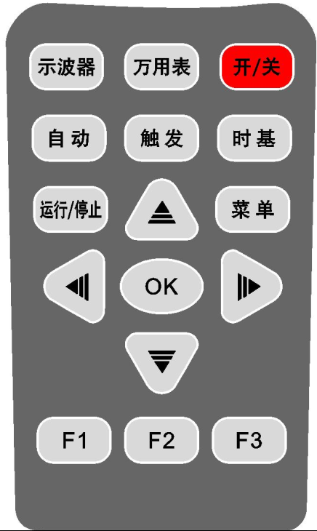
As shown on the right:

JHJDS2022A control button JHJDS2012A control button
All models
CH1、CH2 | Channel 1, Channel 2 settings menu
示波器、万用表 | Press the "示波器" that enters the oscilloscope mode, press the "万用表" into the multimeter mode
PWR | On / Off
AUTO（自动） | Automatically sets the oscilloscope controls, press this key to achieve 50HZ-40MHZ a key trigger function, Channel 1 and Channel 2 can be used
TRIG（触发） | Show "Trigger" control menu
HORI（时基） | Show "Horizontal" control menu
RUN（运行/停止） | Continuously acquires waveforms or stops the acquisition.Note: In the stop mode, the waveform vertical scale and horizontal base can be adjusted within a certain range, equivalent to extend the signal on the horizontal or vertical direction.
MENU（菜单） | Function menu interface, the first press of waveform storage interface, the second press to display settings interface, press three times for the system setup interface
 | To enlarge, shrink waveform, or move the displayed cursor in oscilloscope mode.Used to adjust the range,in the multimeter functions.
 | Can be used to move the waveform display or move the cursor in oscilloscope mode；select the type of test used in the multimeter functions.
OK | Press this button to save the specified waveform that is currently displayed
F1、F2、F3 | Corresponding to the selected setting in the Options menu 1,2,3; as shortcuts in the multimeter functions

2.2 Connector
CH1 CH2 CH1 COM VΩ
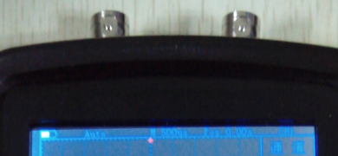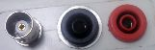
JDS2022A JDS2012A
Figure 2-1 Figure 2-1
Figure 2-1 CH1, CH2: Input connectors for waveform display, the left is CH1, the right is CH2.
Figure 2-2 CH1: used to display the input waveform connection. "COM" and "VΩ" is used to connect the black and red pen.
2.3 Automatically set
JHJDS2022A/JHJDS2012A has an automatic setting function.According to the input signal, automatically adjusting the voltage stall, time base, and triggering the best way to form display.
"AUTO" for automatically setting.
● If there is more than one channel signal, the channel with the lowest frequency signal as the trigger source.
● Found no signal,connect the channel 1 to a signal, press "AUTO" button. As shown in figure 2-3:

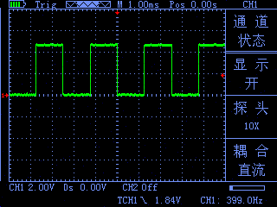

Figure 2-3
2.4 Default settings
JHJDS2022A/JHJDS2012A is set at the factory for routine operations,That is the default setting.In JHJDS2022A/JHJDS2012A "MENU" (or "菜单") has "restore factory mode" operation,Press "F3" to select "restore factory mode" and determine it,Instruments will save and turned off and restore the factory settings,it can be used after the restart.
2.5 Vertical Systems
CH1, CH2 channel and its settings
Each channel has an independent vertical menu.Each item individually set according to different channels.Press CH1 or CH2 function keys.The system displays the Actions menu CH1 or CH2,Description Table 2-1 below:
Table 2-1
Coupling | AC  DC | Blocking the DC component of the input signal.  The ac and dc component of the signal.
Probes | 1X  10X  100X | According to the probe attenuation factor to select one of the values in order to maintain the correct reading of the vertical deflection factor. There are three types: 1X, 10X, 100X
Display | Open  Close | Open display waveforms  Close display waveforms
Frequency | / | Automatically displays the current input signal frequency
peak-to-  peak value | / | Automatically displays the current waveform peak-to-  peak value.

1. Set the channel coupling
To signal applied to CH1 for example, the measured signal is a square wave signal with the AC component.
● Press "CH1" → "Coupling DC", set to DC coupling. DC and AC components of the input signal to pass through.
As Figure 2-4
● Press "CH1" → "Coupling AC", set to AC coupling. DC component of the input signal is blocked.
As Figure 2-5
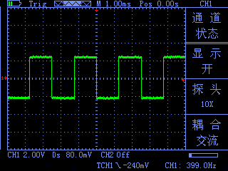
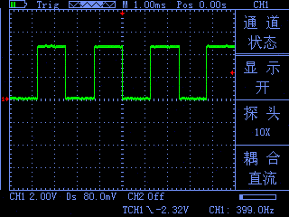
Figure 2-4 Figure 2-5
- Probe scale setting
To cope with the attenuation factor of the probe set,User need adjust the probe attenuation scale factor in channel operation menu.If the probe attenuation coefficient ratio is 10:1,Oscilloscope input channel ratio should be set to 10X,and so on.To avoid the display of information and measurement data errors occur.Take the CH1 for example:
● Press "CH1" → "F2" to set the probe ratio for 10X.
- Waveform display settings
By setting allows any channel waveform display or not display. To let CH1 waveform display and CH2 waveform not display for an example:
● Press "CH1" → "Display ON", set the CH1 channel waveform display. As Figure 2-6
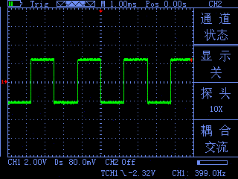
● Press "CH2" →"Show Off",set CH2 channel waveforms are not displayed.As Figure 2-7
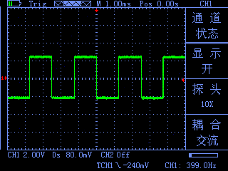

Figure 2-6 Figure 2-7

4 .Vertical volts/division adjustment setting
When adjusting the vertical volts/div, the range is 100mV/div-50V/div (probe 10X),Stepping way to 1-2.5-5,Or 10mV/div-5V/div (probe 1X), 1V/div-500V/div (probe 100X). Take the CH1 for example:

● If you set the vertical direction 2.00V/div,press"CH1"→ " "or " " to adjust the vertical volts / division,press " " or " "to move up and down the entire waveform.As Figure 2-8
● If you set the vertical direction 1.00V/div, the steps in the above example. As Figure 2-9
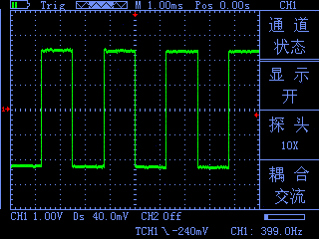
Figure 2-8 Figure 2-9
2.6 Horizontal Systems
Use the control buttons to change the level of the horizontal scale (time base), trigger horizontal position (trigger position) in memory.Changing the horizontal scale causes the waveform relative to the screen center expansion or contraction,Change the horizontal position relative to the change point of the waveform trigger position.
Table 2-2 Main Menu of horizontal time base

● Horizontal scale: Adjust the main group, press the "HORI" button,Press" "or" " to change the scale of the level.To zoom in or out waveform. If you want to stop waveform acquisition, press the "RUN" key can be realized. As Figure 2-10, Figure 2-11

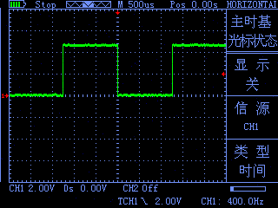
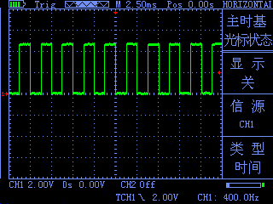

Master time base | Horizontal main time base setting is used to display the waveform
Master time base cursor state | Dsiplay | Set cursor display or not display
Master time base cursor state | Source | Select the measurement signal of the cursor,  That second press "HROI" enter "cursor display" screen  The cursor is displayed here is the opposite of this menu
Master time base cursor state | Type | There are two types of time and voltage
Cursor  display | Cursor1  Cursor 2 | Timebase offset relative to the main vector
Cursor  display | Incremental | Cursor 2 - Cursor 1

Figure 2-10 Figure 2-11
● Horizontal Position: adjust the horizontal position of the waveform (trigger position relative to the center of the screen).Press the "HORI" button,Through " " or " "to move the waveform left or right. The key resolution vary according to time base. Press "AUTO" key can make the horizontal position return to zero.
2.7 Trigger system
The trigger determines when the oscilloscope starts to acquire data and display waveforms.Once the trigger is set up correctly, it can convert the unstable display into meaningful waveforms.Trigger Control menu button" TRIG".
● Trigger Control
Trigger: The oscilloscope trigger mode is edge triggered.
● Edge Trigger: When the edge of the trigger signal reaches a given level,
Trigger occurs.Edge trigger is triggered on the input signal edge trigger threshold.When "Edge",That is input at the rising edge, falling edge triggered.
Table 2-3 Edge trigger function menu
Source | CH1  CH2 | Set CH1 as trigger source.  Set CH2 as trigger source.
Slope | UP  DOWN | Select the trigger signal to trigger on the rising edge  Select the trigger signal to trigger on the falling edge
Trigger mode | Auto  Normal  Single | Set in the absence of detectable also can collect waveform trigger conditions Set only a triggering condition is satisfied only waveform  Set capture a waveform when a trigger is detected, then stop
Operational Status | Display | Choose to display or not display the waveform after the operation status
Operational Status | Operating | Provide CH1 + CH2, CH1-CH2, CH2-CH1 three operations mode
Instructions:
Set the source:
- Press the "TRIG" button to display the trigger menu, according to the signal input, press the "F2" key to select "CH1" or "CH2".
2.Press "CH1", then press" "or" "adjust channel 1 mark.Press the "TRIG", then press" "" "or" "" "adjust the trigger flag arrow,According trigger flag each cell voltage value represents the relative position and the current channel a flag vertically to set the trigger level size.
Set slope:
- Press the "F1" key to select slope "up" or "down."
Set trigger mode:
- Press the "F3" key to select "Auto", "normal" or "single."
Auto :Set in the absence of detectable also can collect waveform trigger conditions
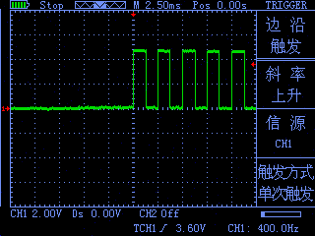
Normal :Set only a triggering condition is satisfied only waveform Single :Set capture a waveform when a trigger is detected, then stopAs Figure 2-12

Figure 2-12
2.8 Display System
Table2-4 Display system function menu
Function Menu | Setting | Instruction
Display Type | Vector | Samples display through connection;
Format | Y-T | Display Voltage(Vertical Line)-Time(Horizontal Line) Curve
Continue | / | Waves update in Real time;
Display Lighting | BackLight | Adjust from 1 to 5;
Color | / | Full color or Blacn&White
Language | / | Simplified Chinese and English

Display System Setup
1.BackLight:Press“MENU”,find“Setup Display”,press”F1”to set “Backlight(Bright)”;Adjust from 1 to 5;
2.Language:Press”MENU”,find”Setup Display”,press “F2” to set “Language”;can be set to “中文” or “English”.
3.Color:Press “MENU”,find “Setup Display”,press “F3”;can be set to “1” for “Black&White”,”2” for “Full color”.

2.9 Storage System
JHJDS2012A Series products can save two reference waveforms、six screenshots at internal memories.
JHJDS2012A Series products support USB interface,using for exporting screenshots(bmp picture) to u-disk.In addition,The saved two reference waves can be shown in “MENU-Waveform Save”.
The way to export screenshots:shut down the device,connect to computer by a usb cable,the press “OK” and “PWR” at the same time,after the screen is worked,let go;Now,you will see a U-Disk on your computer.After you get your pictures,please click Safely Remove USB Device on your computer first,then disconnect the usb cable;you should unplug the battery and then plug it at last.
Waring:Please don’t use any measure function when the usb cable is connecting with other devices,or this Instument Will Be Damaged.

2.10 Auxiliary Systems
Auxiliary function can be enabled by press “MENU” 、“F1” “F2” “F3”.
"MENU" button to pop up the system function settings menu. Table 2-5
Table 2-5
Menu | Setting | Instruction
Low power | Sound | Open or Close
Low power | Auto Shut Down | 10min 、30min、or Never(means if no opearting within this times,the system will shut down)
Low power | Low light | 20s、40s、60s、300s or Never(means if no opearting within this times,the system will start Low Light Mode)
Set Manufacturers | Screenshot Settings | PRCSRC | Open or Close
Set Manufacturers | Screenshot Settings | Picture | Max value is 6
Set Manufacturers | Firm-mode Restore | Restore factory settings

2.11 Multimeter function and operation
This device can be used as a Multimeter or OSC; Can be used for measuring DC and AC voltage, resistance, capacitance, diode, buzzer-off . This device uses TFT full color display, and has a range display, olarity display, overload display, battery power display.

Measure Type | Range
DC Voltage | 400.0mV |  | 4.000V |  | 40.00V |  | 400.0V |  | 1000V
AC Voltage | 400.0mV |  | 4.000V |  | 40.00V |  | 400.0V |  | 750V
Resistance | 400.0Ω | 4.000KΩ |  | 40.00KΩ |  | 400.0KΩ |  | 4.000MΩ | 40.00  MΩ
Capacitance | 51.2nF |  | 512.0nF |  | 5.120uF |  | 51.20uF |  | 100uF
Diode | 0V-1.5V
Buzzer-off | Below 60Ω ,buzzer alarm

DC or AC
Electricity
Running state

Display manually or automatically

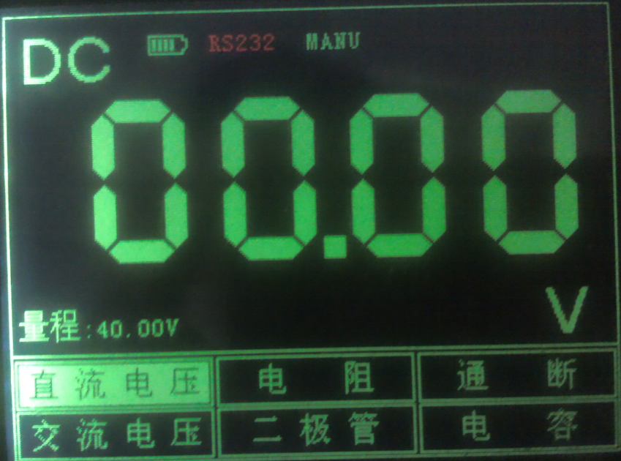

Meter Interface

Measure Method:
Table2-7 Multimeter Operation Key Function
Key | Description
万用表  Multimeter | Press this key to enter Multimeter Mode.
 | Press “ ” or “ ” to select Mesure Type
 | Press “ ” or “ ” to tune the Range
F1 | Shortcut for “DC Voltage” measure.
F2 | Shortcut for “Resistance” measure.
F3 | Shortcut for “Buzzer-Off” measure.
运行/停止  RUN/STOP | Multimeter’s RUN/HOLD key.

Note 1: Multimeter’s default range is "Auto" position, for manually setting the range, first predicted your Measurements..
Note 2:Display screen show flashing “RS232”means Multimeter is running;”MANU” means manually set the range.
⒈ DC and AC Voltage measuring
- The Black Pen connect to the COM interface on the top of the device(the black interface),and the Red Pen connect to VΩ interface(the red interface)
- Press “ON/OFF” key until the system is started,then press “Multimeter” key to switch to Multimeter Function.
③ Press “ ” or “ ” to select “DC voltage” or “AC Voltage” measuring.”DC Voltage” has a Shortcut,”F1”.
④ Connect the test pen to the measured voltage,the device will read the value and show on the screen(it can also read negative value.).AC Voltage has no polarity.This device’s default Range is “Auto”,you can press “ ” or “ ” to change the Range.
⒉ Resistance measuring
① Press “ ” or “ ” to select Resistance mesuare.it has a shortcut,”F2”.
② Put the pen on the two side of the resistor,device can read it’s value.Maybe you shoud set the Range manually.

⒊ Capacitance measuring
① Press “ ” or “ ” to select Capacitance mesuare.
② Put the pen on the two side of the capacitance,device can read it’s value.
Note: Capacitance measuring can’t set Range.

⒋ Diode and Buzzer-off measuring
① Press “ ” or “ ” key to select “Diode” or “Buzzer-off” measuring.Buzzer-off measuring has a shortcut ,”F3”.
② Put the pen on the two side of the Diode or the line,device can read it’s value.(The value when measuring diode,it’s diode Conduction voltage drop)
③ When mesuareing resistance is below 60Ω,buzzer alams.
Attention:
a.The device has forward and reverse voltae,when the diode connected reversed,the value is negative.
b.Diode and Buzzer-off mearusing only have “Auto” Range.
c.When measuring,must keep “Sound” On,or the Buzzer can’t alarm.
Ways to setup:
（1）Press “OSC” key to start OSC mode,and press “MENU”,then find “Set Low power”.
（2）Press F2 to Open or Close Sound.

⒌ Data Hold Function
"Run / Stop" button is pressed on the instrument, the data will remain being displayed on the display even if the input signal changes, or eliminate, the value is not changed

Waring 1:When using Multimeter,the OSC dector must not connect to GROUND.
Waring 2:Please select the appropriate Range before measure object.
Waring 3:When the usb cable is connect to other devices,must not measur,or the device will be damaged.
Chapter III Application Examples
3.1 Singal measure
Measure an unknown singal,and show it’s value immediately.
- If you want show the value immediately ,please do as fllows:
- Set the probe menu attenuation coefficient as 10X, and switch the probe to 10X.
- Connect the CH1 probe to the test point.
③ Press “AUTO” key.
The OSC will automatically set the optimun vaveform display.Then you can adjust the Vertical or Horizontal scale,until the waveform meets your requirements.
- Automatic measure singal’s voltage and time parameter.
The OSC can automatic measure most signals.To measure the frequency and peak-peak,follw the steps:
- Press “AUTO” key,show current waveforms.
- Press “CH1” key to turn the page,and you can observed frequency and peak-peak.
At this time, frequency, and peak measurements are shown in the "F2" and "F3" corresponding position.See Figure 3-1.

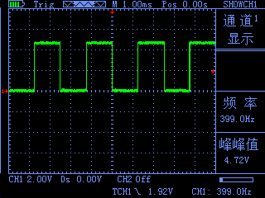

3.2 Cursor measure
This OSC can automatic measure a variety of waveform
parameters.All measurement parameters can be measured
by the cursor.Use the cursor,can measure the waveform
parameters quickly.
- Measuring the peak voltage of square wave signal. Figure 3-1
Take the CH1 for example.if you want to measure the peak voltage of a square wave signal,do as follows:
- Press “HORI” key to enter the main base cursor
state seting.
②Press “F1” key to set the cursor “ON”;Press “F2” key to set the source as “CH1”;press “F3” key to set the type of the cursor “Voltage”.
③Press “HORI” key again to see location of cursor 1 and cursor 2(relative to the intermediate zero volate reference level) and increment(V_cursor2-V_cursor1)

④ Press “ ” and “ ” to tune the position of cursor 2,“ ” and “ ” to tune the position of cursor 1;and there position and increment will updating on the screen in Real-time.See Pic 3-2 and Pic 3-3.

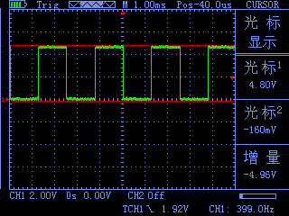
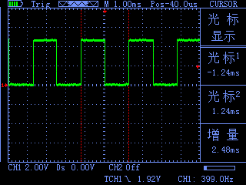

Figure 3-2 Figure3-3

3.3 Capture the Single Signal
Digital storage oscilloscope advantages and features that could easily capture the aperiodic signal pulses, glitches, etc. To capture a single signal, this signal first need to have some prior knowledge, in order to set the trigger level along. If the case of a signal of uncertainty, you can automatically trigger mode or normal first observation to determine the trigger level along.
Steps are as follows:
1、As aforementioned, set the attenuation coefficient of probe and CH1 channel to 10X.
2、Trigger settings:
- Press "CH1 key" → press "F3" key to set the coupling to "DC."
- Press the "TRIG" button to display the edge trigger menu settings.
 In this menu,press “F1” key to set the edge type “slope down”,press “F2” key to set the source “CH1”,press “F3” key to set the trigger mode to “single”.

④ Press “RUN” key,the left corner of the display
screen will displays “Ready”,waiting for the
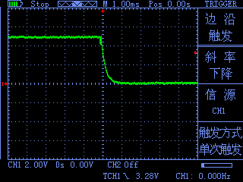
signal meets the trigger condition occurs.If
the trigger signal reaches the ertain conditions,
it will displays on the screen.With this feature
you can easily capture the event accidental,such
as a suddenly low voltage:press”RUN” key to
start the wait when there is a low level occurs,
the devices will automatically trigger and the
trigger waveform record before and after a period
of time off.”HORI” key can change the horizontal
position of the trigger position,then you can
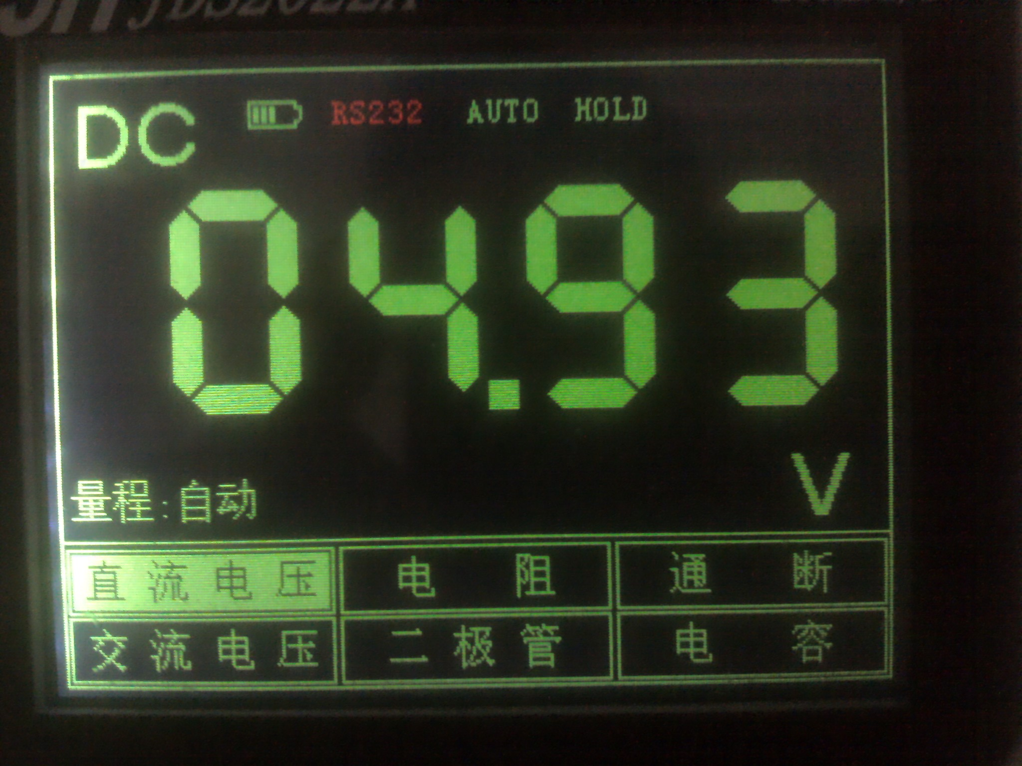
get different lengths,which can easily observe the Figure 3-4 waveform. See Figure 3-4

3.4 Use Multimeter to Measure DC Voltage

- Use “AUTO” measure DC Voltage.
① Press “万用表”key,enter Multimeter mode,
Auto range default.
② Press “ ” or “ ” to select “DC Voltage”,
Figure 3-5
or press “F1”key.
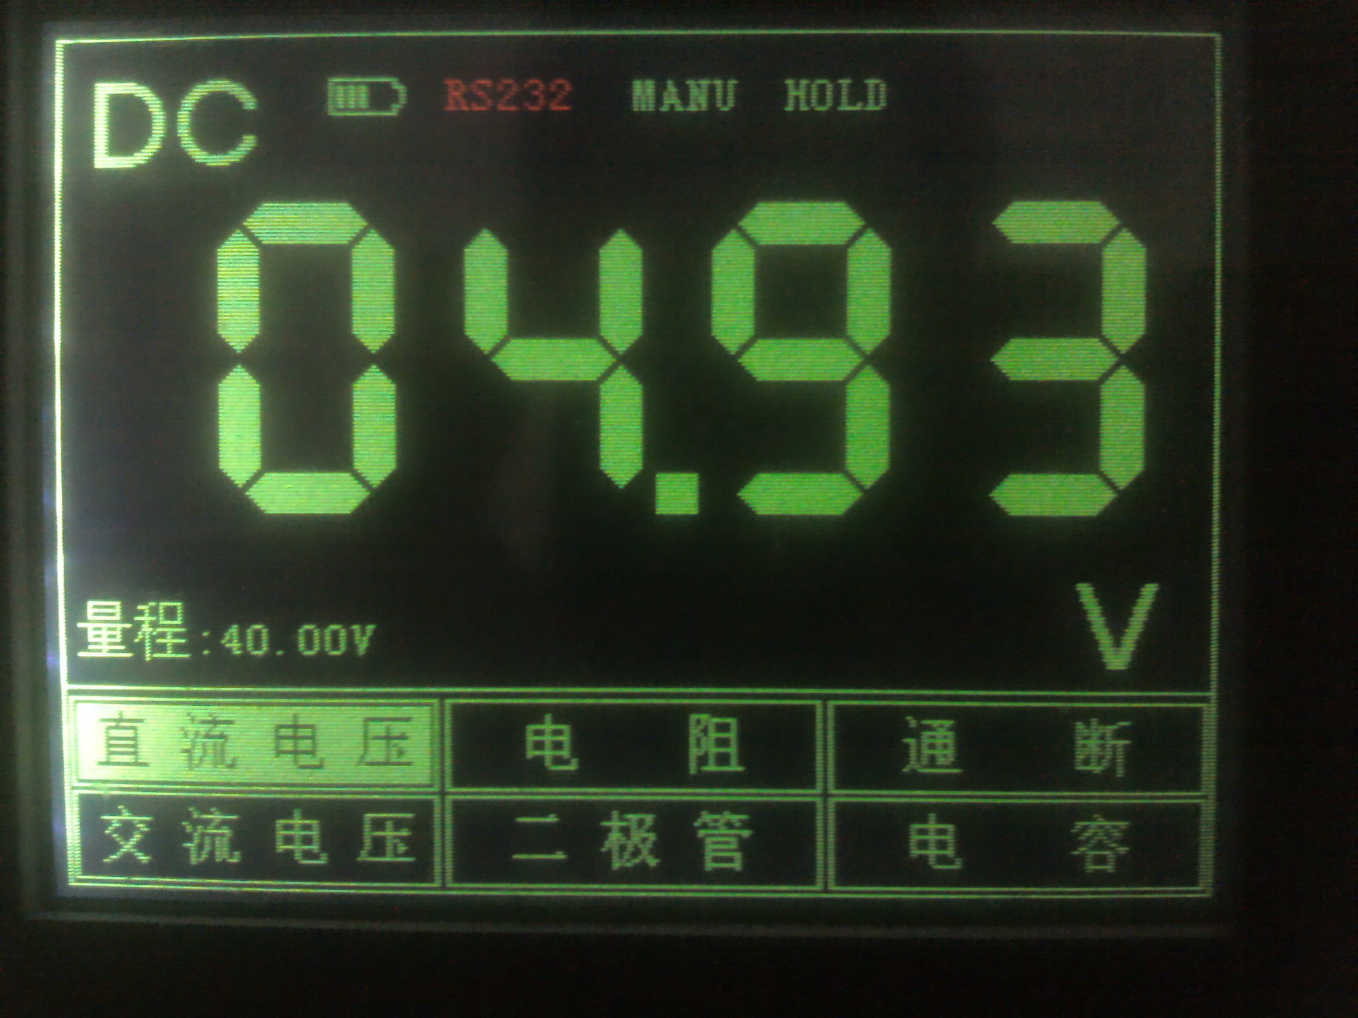
③ Put the pen on the test point,and it will read The value.See figure 3-5.
- Set the Voltage Range manually.
① Press “ ” or “ ” to select “DC”,or
press “F1”.
② Press “ ” or “ ” to adjust the range.
See figure 3-6.

Figure 3-6

Chapter 4 System Tips and Troubleshooting

4.1 Prompting Message
Trigger level limit:
Horizontal position limit:
Voltage range limit:
USB storage device is connected successfully:
4.2 Troubleshooting
1.If you press the "PWR" button oscilloscope screen remains dark, no display, follow these steps:
(1) Open the instrument battery cover, check whether the power supply or battery power leakage, flatulence, etc.
(2) After the inspection is completed, restart the instrument.
(3) If you still can not properly use the product, please contact us.
2.After signal acquisition, signal waveform screen does not appear, please follow these steps:
(1) Check whether the probes is correctly connected to the signal line connection.
(2) Check whether the signal cable is properly connected to the BNC.
(3) Check whether the probe is properly connected with the analytes.
(4) Check whether the analyte signal is generated.
(5) re-acquire the signal again.
3.Measured voltage amplitude value is 10 times greater than the actual value, or 10 times smaller:
Check whether the channel attenuation factor of the probe matches the actual attenuation ratio.
4.There waveform display, but not stable:
Check the trigger source trigger menu settings are consistent with the actual signal input channels.
5.Press "RUN" button without any display:
Trigger checks whether the trigger menu in the "normal" or "Single" and the trigger level has been exceeded if the signal range. If it is, the trigger level is centered, or set the trigger mode to "AUTO" file.
- Stepped waveform display:
This phenomenon is normal. When the base level is too low may stall, increasing the level of the base when the horizontal resolution can be increased to improve the display.

Chapter V service and support
5.1 Warranty Description
We guarantee the production and sale of its products, the date of shipment from authorized dealers within a year, does not appear in material and workmanship defects.As specified in the detailed product warranty proved defective, we will provide repair or replacement service.
In addition to this summary, or use the warranty provision of the warranty, we do not make any other warranties, express or implied. The Company's indirect, special or damage arising therefrom shall not be liable.
Appendix A: Technical Specifications
Unless otherwise noted, all technical specifications are used for attenuation switch setting 10X probes and this series oscilloscopes.
To verify that the oscilloscope meets specifications, the oscilloscope must meet the following conditions:
●The oscilloscope must be more than thirty minutes of continuous operation within the specified operating temperature.
●If the operating temperature changes by more than 5 degrees, will have to be corrected, unless labeled "typical" outside the specifications, all specifications are guaranteed.
●Oscilloscope must be within the factory calibration interval.
Technical Specifications
import
Input coupling | AC、DC
Input impedance | 1MΩ 25pF
The maximum input voltage | 40V (probe X1); 400V (probe X10) can be measured 220V voltage; (probe X100) 2000V voltage can be measured
Probe attenuation | 1X、10X
Set the probe attenuation factor | 1X、10X、100X
Signal acquisition system
Sampling Method | Real-time sampling, random sampling
Memory depth | 4K (per channel for each 2K)
Acquisition Mode | Sample, Peak Detect
Vertical System
Vertical Sensitivity | 10mV-5V (Probe 1X) 100mV-50V (probe 10X) (1,2.5,5 step)
Vertical accuracy | +/-3%
Vertical resolution | 8bit
Bandwidth | 20MHz
Horizontal Systems
Real-time sampling rate | 200 MSa/s
Horizontal scan range | 10nS/div-5S/div
Trigger System
Mode | Auto, Normal and Single
Type | Rising edge trigger, falling edge trigger
Automatic detection | Support (50Hz-40MHz)
Math | CH1+CH2、CH1-CH2、CH2-CH1
Measurement System
Cursor measurements | Support time and voltage cursors
Measurements | Manual
Measure | Peak and frequency
Equipment
Screen | 3.2-inch, 16-bit true color, TFT, 320 * 240
Battery | 3000 + mA lithium battery (single cell about four hours of continuous work)
Size | 202 * 100 * 35 (mm)

Appendix B JHJDS2012A handheld digital storage oscilloscope accessories
Standard accessories:
● A user manual ● A 1:1 / 1:10 probe ● A certificate
● Lithium battery × 1 ● A lithium battery charger ● One pair of multimeter pen
Appendix C: routine maintenance and cleaning
Routine maintenance
Do not store or leave the instrument in where the LCD display will be exposed to direct sunlight for a long time.
Do not allow sprays, liquids and solvents touches on the instrument or probe, to avoid damage to the instrument and probe.
Please charge the battery in the battery is finished using the situation.
Clean
Regularly inspect the instrument and probe according to operating conditions.
Please follow the steps below to clean the outer surface of the instrument:
1.Use external dust soft cloth to wipe the instrument and probe. When cleaning the LCD screen, be careful not to scratch the clear plastic protective screen.
2.Use a damp but not dripping, soft cloth to wipe the instrument, please remove the battery before wiping. Use a mild detergent and water to scrub. Do not use any corrosive chemicals, to avoid damage to the instrument and probe.
WARNING: Before reinstalling the battery, make sure the instrument is completely dry to avoid water damage to equipment caused by electrical short circuit.

